Project
Deadline: Monday 09/08/2026 @ 23:59
[Total Mark is 20]

Fundamentals of Database
IT403

Instructions:
You must submit two separate copies (one Word file and one PDF file) using the Assignment Template on Blackboard via the allocated folder. These files must not be in compressed format.
It is your responsibility to check and make sure that you have uploaded both the correct files.
Zero mark will be given if you try to bypass the SafeAssign (e.g. misspell words, remove spaces between words, hide characters, use different character sets, convert text into image or languages other than English or any kind of manipulation).
Email submission will not be accepted.
You are advised to make your work clear and well-presented. This includes filling your information on the cover page.
You must use this template, failing which will result in zero mark.
You MUST show all your work, and text must not be converted into an image, unless specified otherwise by the question.
Late submission will result in ZERO mark.
The work should be your own, copying from students or other resources will result in ZERO mark.
Use Times New Roman font for all your answers.
Name: Mohammed Alsaleem  Name: Mohammed Alhumud  Name: Adel Almalki  Name: Abdulrahman Alabdulwahid |  | ID: S220012336  ID: S230038199  ID: S230051018  ID: S220030249

Project Instructions
- You can work on this project as a group (minimum 3 and maximum 4 students). Each group member must submit the project individually with all group member names mentioned on the cover page.
- This project worth 20 marks and will be distributed as in the following:
  - Database Design. (6 marks)
  - Database Implementation. (6 marks)
  - SQL Operations. (6 marks)
  - Project Reflection. (2 marks)
- Each leader in the group must submit one report about their chosen Project via the Blackboard (Email submission will not be accepted and will be awarded ZERO marks) containing the following:
- Task 1 : database design
- Task 2: database implementation
- All requested queries/results
- Screenshots from MySQL (or any other software you use) of all the tables after population and query results.
- Reflection (300–500 words) describing the team's experience, challenges, design decisions, and AI usage (if applicable).
- Submit one SQL file containing the complete database implementation, including database creation, tables, data insertion, required queries, VIEW, and TRIGGER.
- Submit a GitHub (or GitLab) repository containing the complete project with regular commits and meaningful commit messages.
- Submit a progress report describing the completed work, key decisions, challenges, future plan, and contribution of each group member.
- Include links to the live report document, GitHub/GitLab repository, and Google Colab notebook (if applicable) in the Project Artifacts section of the final report.
- You are advised to make your work clear and well presented; marks may be reduced for poor presentation. This includes filling in your information on the cover page.
- You MUST show all your work, and text must not be converted into an image unless specified otherwise by the question.
- Late submission will result in ZERO marks being awarded.
- The work should be your own. Copying from students or other resources, including AI software, will result in ZERO marks.

Project Description
Design and Implementation of a Smart Clinic Database System
Learning Outcome(s):

CLO1, CLO2, CLO3, CLO4, CLO5

A private clinic currently manages its patient information manually, making it difficult to organize appointments, treatments, and payments. The clinic has decided to develop a database system to improve data organization and retrieval.
Your team is required to design, implement, and test a complete relational database using the concepts learned throughout this course. The project should demonstrate your understanding of database design, ER/EER modeling, relational mapping, SQL implementation, and advanced SQL queries. The project must be completed using MySQL.

Task 1 – Database Design (6 Marks)
- Design a complete database for the clinic that includes at least six entities such as Patients, Doctors, Appointments, Treatments, Medicines, Payments, or any other appropriate entities.
- A complete ER/EER diagram.
- Primary and foreign keys.
- Appropriate relationships with cardinality.
- At least one specialization/generalization (EER feature).
- Any assumptions made during the design process.

Answer:
ER diagram:
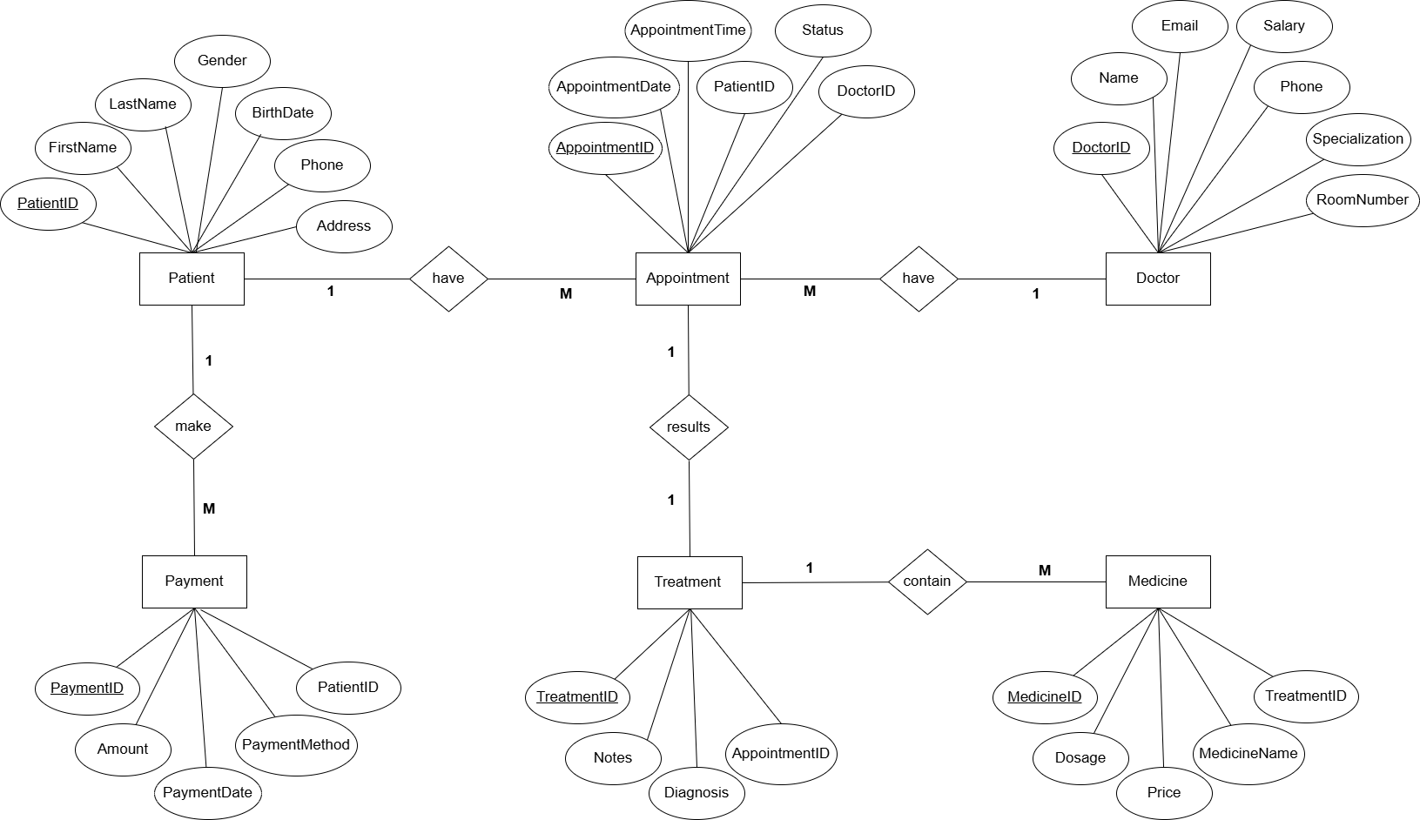
Table | Primary Key | Foreign Key
Patient | PatientID | -
Doctor | DoctorID | DoctorID
Appointment | AppointmentID | PatientID, DoctorID
Treatment | TreatmentID | AppointmentID
Medicine | MedicineID | TreatmentID
Payment | PaymentID | PatientID

EER diagram:
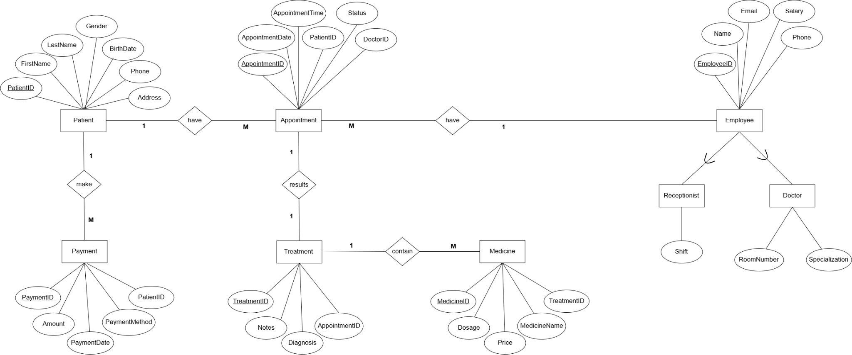

Assumptions:
- Each patient can have multiple appointments
- Each appointment belongs to one patient
- Each appointment is handled by one doctor
- Each treatment is linked to one appointment
- A treatment may include multiple medicines
- A patient may make multiple payments
- Every doctor and receptionist is an employee

Task 2 – Database Implementation (6 Marks)
Complete the following tasks using MySQL. Include screenshots of both your SQL code and the corresponding output (results) for each task:
- Create the database and all required tables.
- Use appropriate data types and constraints (PRIMARY KEY, FOREIGN KEY, NOT NULL, UNIQUE, etc.).
- Insert at least 5 records into each main table.

Answer:
CREATE DATABASE SmartClinic;
Screenshot:
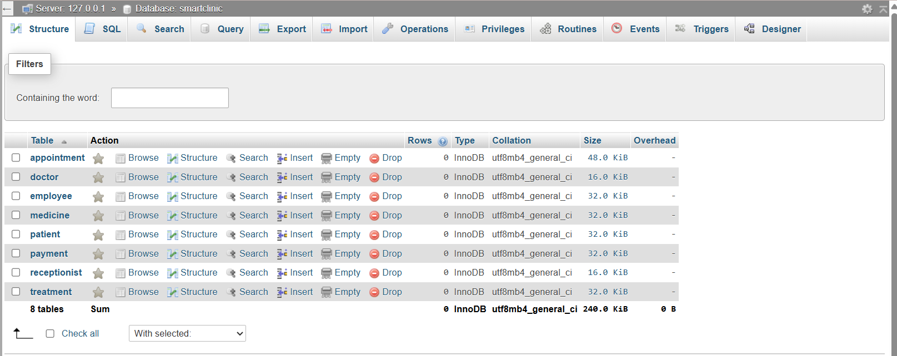

CREATE TABLE Patient (
PatientID INT AUTO_INCREMENT PRIMARY KEY,
FirstName VARCHAR(50) NOT NULL,
LastName VARCHAR(50) NOT NULL,
Gender ENUM('Male','Female'),
BirthDate DATE,
Phone VARCHAR(20) UNIQUE,
Address VARCHAR(100)
);
Screenshot:
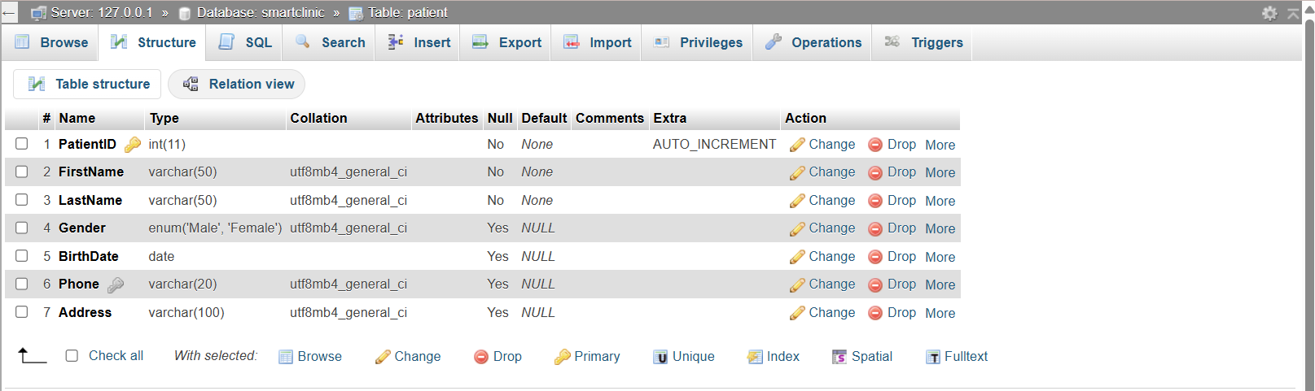

CREATE TABLE Employee (
EmployeeID INT AUTO_INCREMENT PRIMARY KEY,
Name VARCHAR(100) NOT NULL,
Phone VARCHAR(20),
Email VARCHAR(100) UNIQUE,
Salary DECIMAL(10,2)
);
Screenshot:
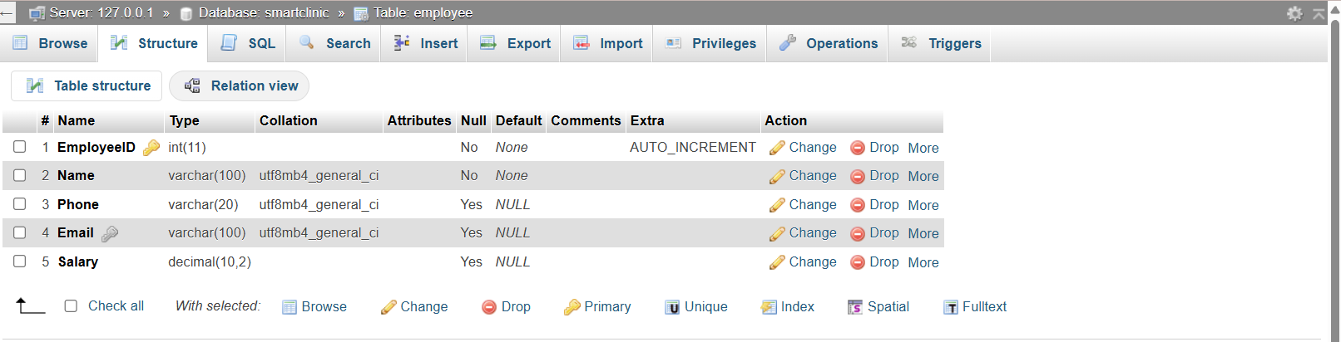

CREATE TABLE Doctor (
EmployeeID INT PRIMARY KEY,
Specialization VARCHAR(50),
RoomNumber VARCHAR(10),
FOREIGN KEY (EmployeeID) REFERENCES Employee(EmployeeID)
);
Screenshot:
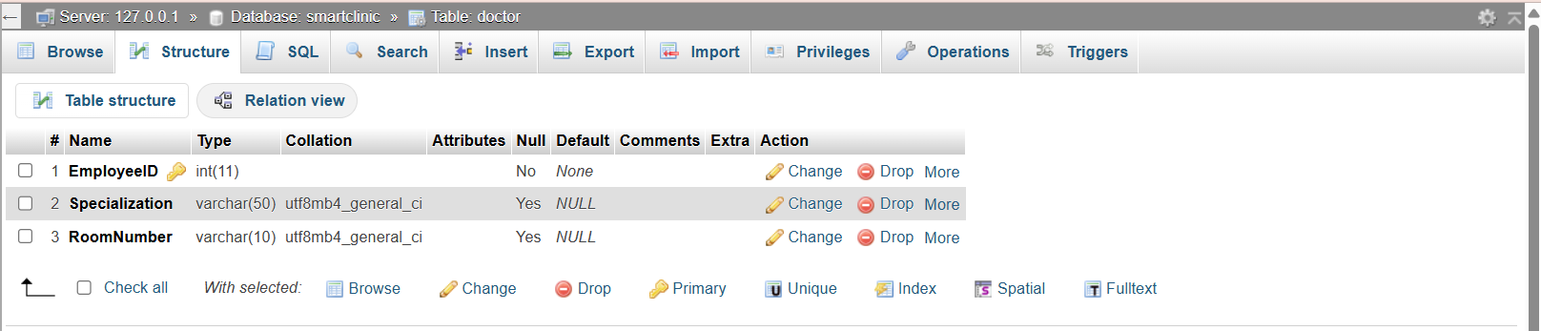

CREATE TABLE Receptionist (
EmployeeID INT PRIMARY KEY,
Shift VARCHAR(20),
FOREIGN KEY (EmployeeID) REFERENCES Employee(EmployeeID)
);
Screenshot:
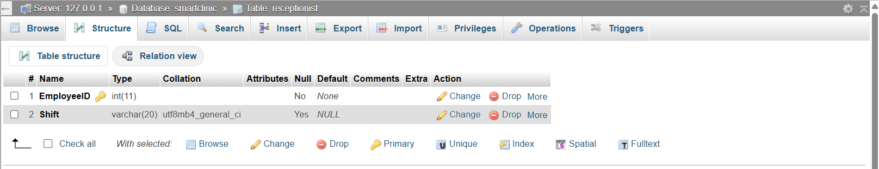

CREATE TABLE Appointment (
AppointmentID INT AUTO_INCREMENT PRIMARY KEY,
AppointmentDate DATE NOT NULL,
AppointmentTime TIME NOT NULL,
Status VARCHAR(20),
PatientID INT NOT NULL,
DoctorID INT NOT NULL,
FOREIGN KEY (PatientID) REFERENCES Patient(PatientID),
FOREIGN KEY (DoctorID) REFERENCES Doctor(EmployeeID)
);
Screenshot:
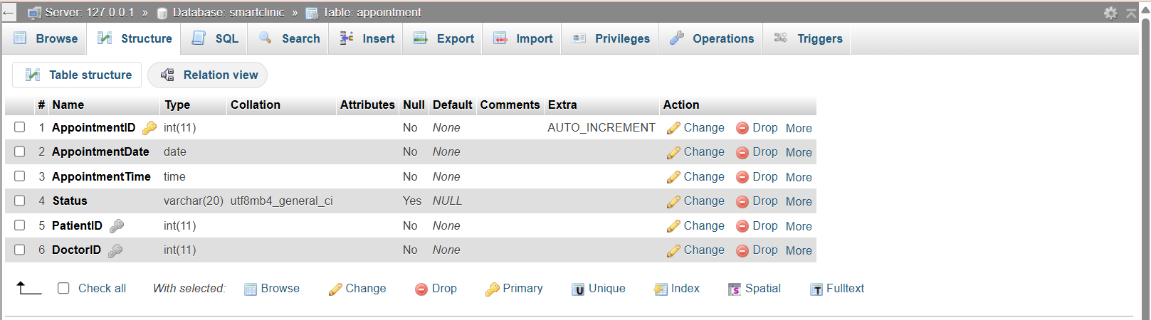

CREATE TABLE Treatment (
TreatmentID INT AUTO_INCREMENT PRIMARY KEY,
Diagnosis TEXT,
Notes TEXT,
AppointmentID INT UNIQUE,
FOREIGN KEY (AppointmentID) REFERENCES Appointment(AppointmentID)
);
Screenshot:
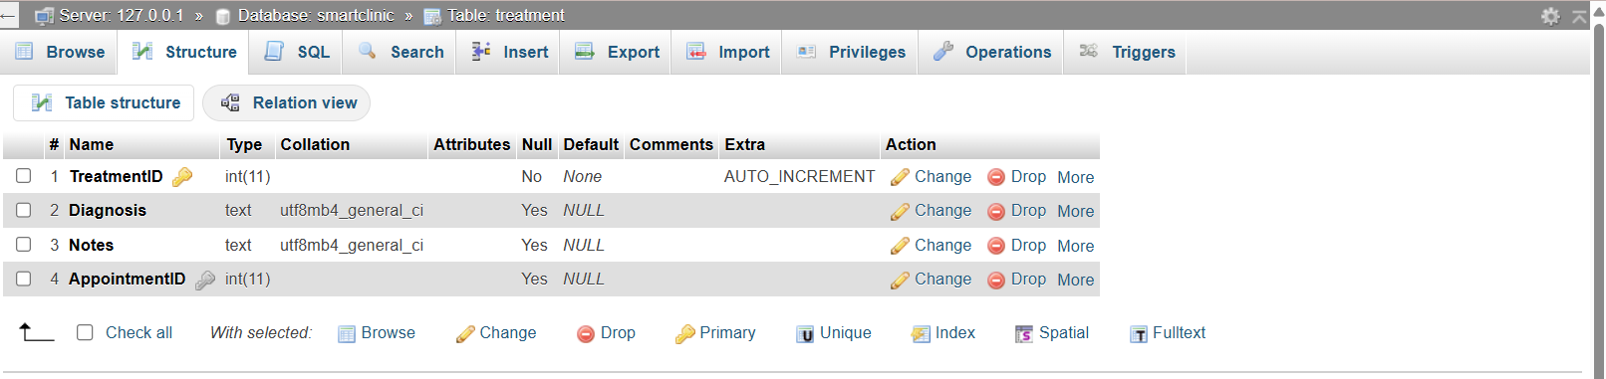
CREATE TABLE Medicine (
MedicineID INT AUTO_INCREMENT PRIMARY KEY,
MedicineName VARCHAR(100),
Dosage VARCHAR(50),
Price DECIMAL(8,2),
TreatmentID INT,
FOREIGN KEY (TreatmentID) REFERENCES Treatment(TreatmentID)
);
Screenshot: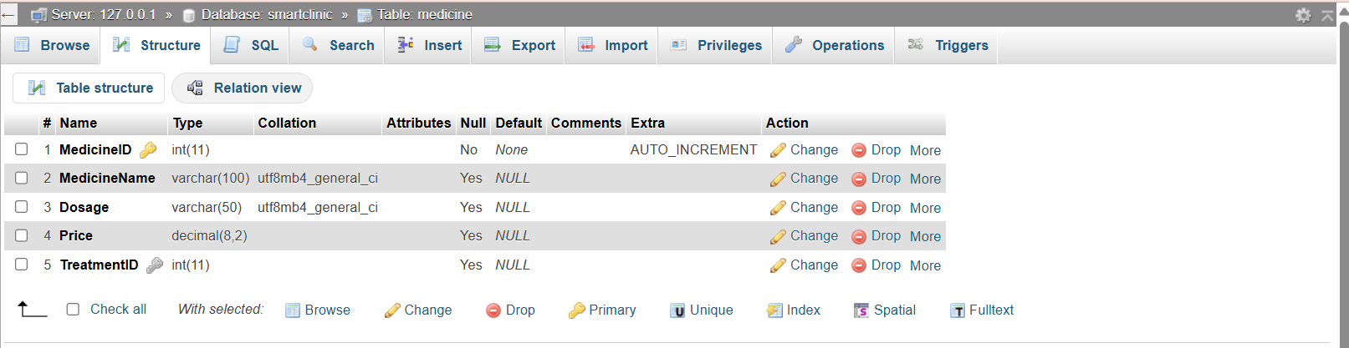

CREATE TABLE Payment (
PaymentID INT AUTO_INCREMENT PRIMARY KEY,
Amount DECIMAL(8,2),
PaymentDate DATE,
PaymentMethod VARCHAR(30),
PatientID INT,
FOREIGN KEY (PatientID) REFERENCES Patient(PatientID)
);
Screenshot:
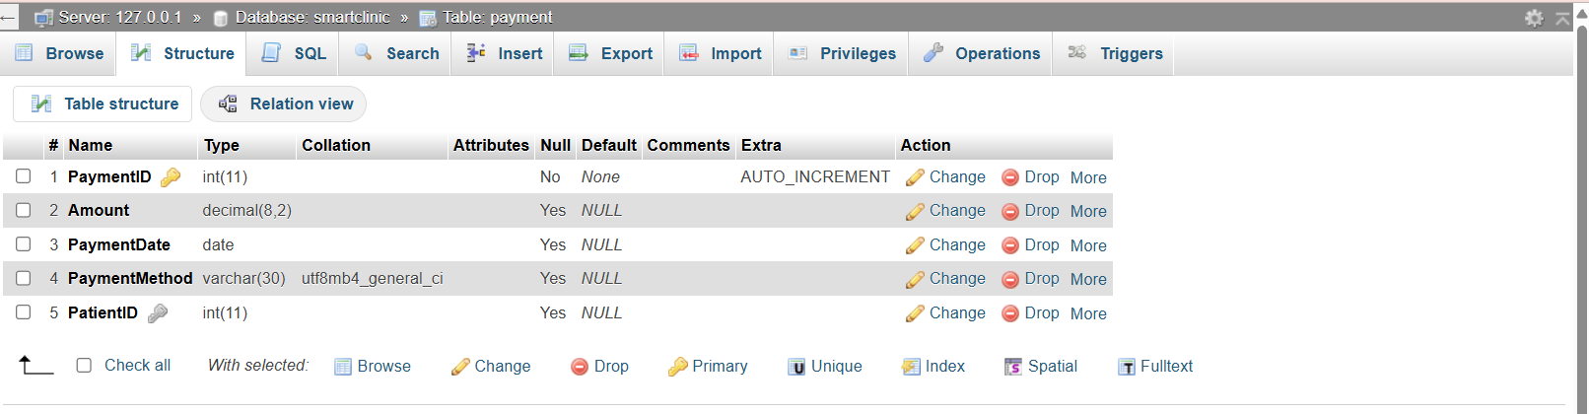

INSERT INTO Patient(FirstName,LastName,Gender,BirthDate,Phone,Address) VALUES
('Mohammed','Alsaleem','Male','2002-01-10','01011111111','Cairo'),
('Mohammed','Alhumud','Male','2001-05-11','01022222222','Giza'),
('Adel','Almalki','Male','1998-08-20','01033333333','Alex'),
('Mona','Ibrahim','Female','2000-12-15','01044444444','Tanta'),
('Abdulrahman','Alabdulwahid','Male','1997-03-30','01055555555','Mansoura');
Screenshot:
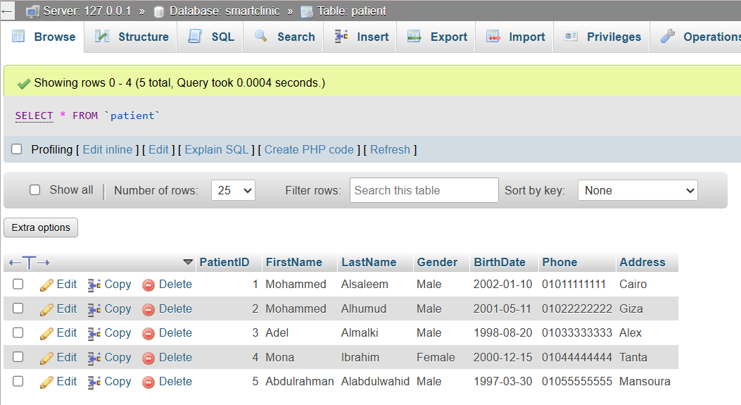

INSERT INTO Employee(Name,Phone,Email,Salary) VALUES
('Dr. Ahmed', '01111111111', 'ahmed@clinic.com', 20000),
('Dr. Sara', '01122222222', 'sara@clinic.com', 18000),
('Nour', '01133333333', 'nour@clinic.com', 6000),
('Mona', '01144444444', 'mona@clinic.com', 6500),
('Dr. Ali', '01155555555', 'ali@clinic.com', 22000),
('Dr. Omar', '01166666666', 'omar@clinic.com', 21000),
('Dr. Hany', '01177777777', 'hany@clinic.com', 19500),
('Salma', '01188888888', 'salma@clinic.com', 6200),
('Yasmine', '01199999999', 'yasmine@clinic.com', 6400),
('Laila', '01200000000', 'laila@clinic.com', 6100);
Screenshot:
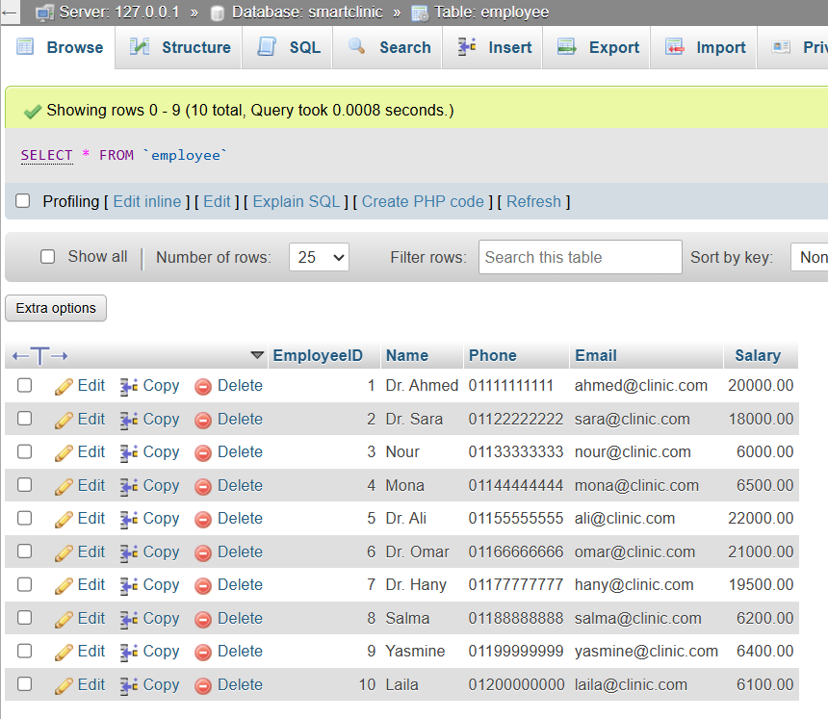

INSERT INTO Doctor VALUES
(1, 'Cardiology', 'A1'),
(2, 'Dentistry', 'B3'),
(5, 'Orthopedics', 'C2'),
(6, 'Dermatology', 'D1'),
(7, 'Neurology', 'E2');
Screenshot:
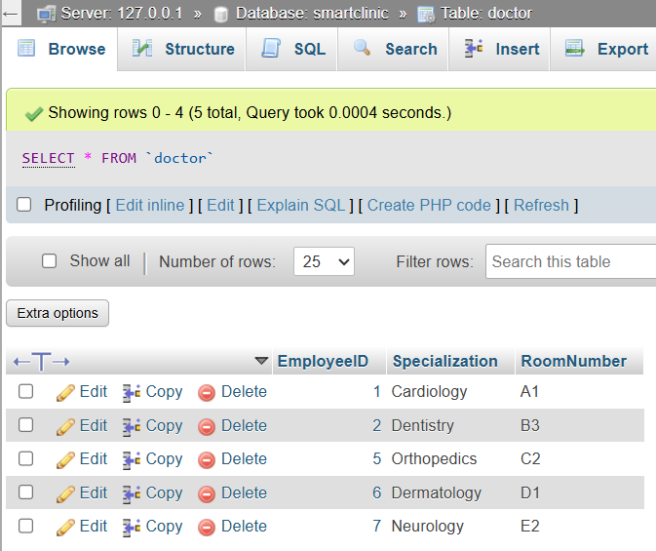

INSERT INTO Receptionist VALUES
(3, 'Morning'),
(4, 'Evening'),
(8, 'Morning'),
(9, 'Evening'),
(10, 'Morning');
Screenshot:
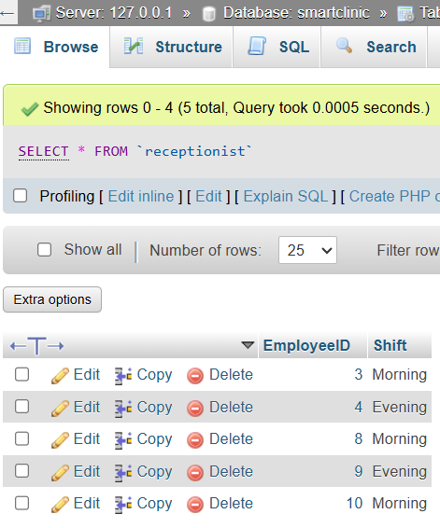

INSERT INTO Appointment (AppointmentDate,AppointmentTime,Status,PatientID,DoctorID) VALUES
('2026-08-01', '10:00:00', 'Completed', 1, 1),
('2026-08-01', '11:00:00', 'Completed', 2, 2),
('2026-08-02', '09:30:00', 'Pending', 3, 5),
('2026-08-03', '12:00:00', 'Completed', 4, 6),
('2026-08-04', '01:00:00', 'Pending', 5, 7);
Screenshot:
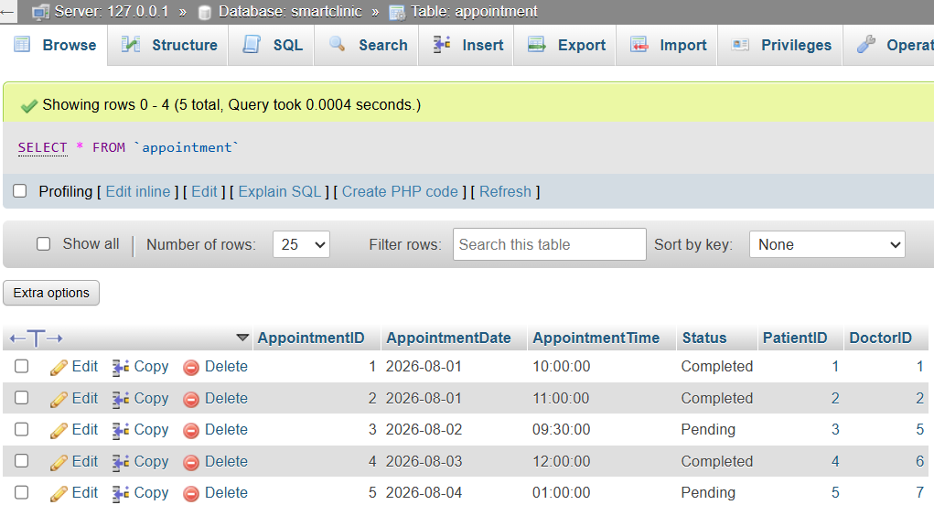

INSERT INTO Treatment(Diagnosis,Notes,AppointmentID) VALUES
('Flu','Take rest',1),
('Tooth Pain','Need filling',2),
('Back Pain','Physiotherapy',3),
('Fracture','X-Ray',4),
('Checkup','Healthy',5);
Screenshot:
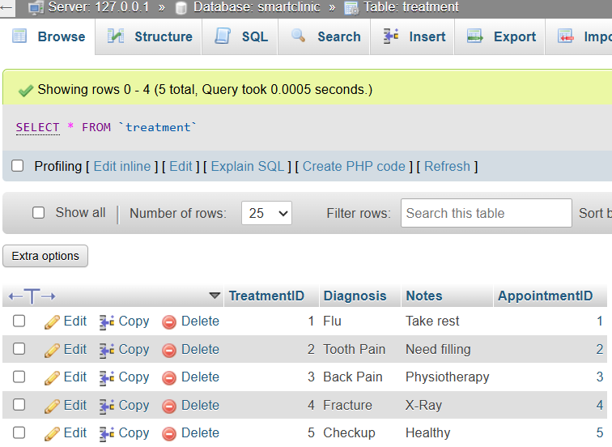

INSERT INTO Medicine(MedicineName,Dosage,Price,TreatmentID) VALUES
('Panadol','2/day',50,1),
('Augmentin','3/day',120,1),
('Ibuprofen','1/day',70,2),
('Vitamin D','1/day',90,3),
('Calcium','1/day',110,4);
Screenshot:
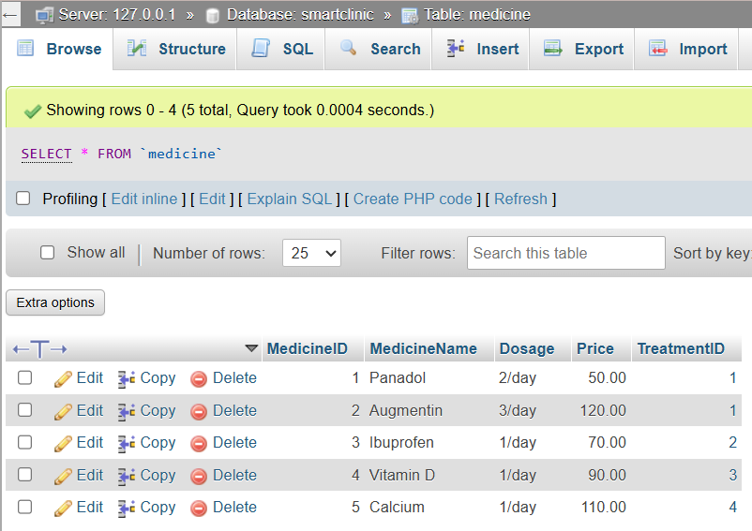

INSERT INTO Payment(Amount,PaymentDate,PaymentMethod,PatientID) VALUES
(300,'2026-08-01','Cash',1),
(450,'2026-08-01','Visa',2),
(350,'2026-08-02','Cash',3),
(700,'2026-08-03','Visa',4),
(250,'2026-08-04','Cash',5);
Screenshot:
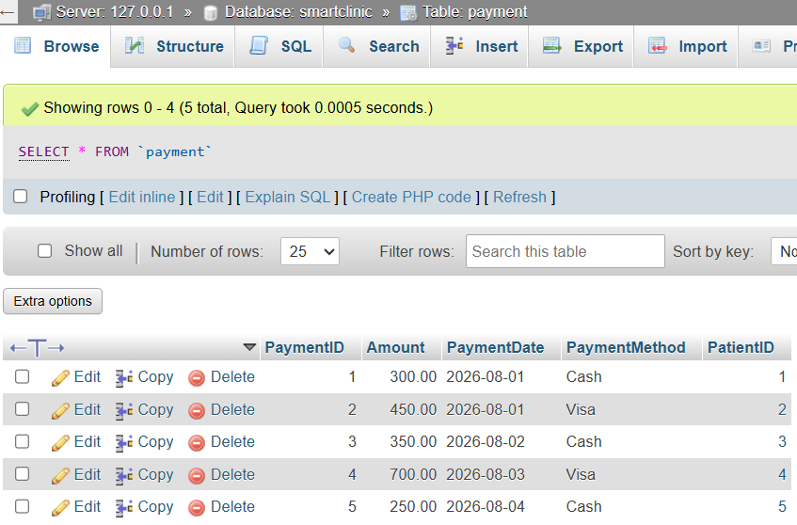

Task 3 – SQL Operations (6 Marks)
Complete the following tasks using MySQL. For each task, include screenshots of both your SQL code and the corresponding output (results), along with a brief description (one to two sentences) explaining the purpose of the query and the information it is intended to retrieve.
- Write SELECT statements.
- Write JOIN queries.
- Write nested queries.
- Use aggregate functions with GROUP BY.
- Write UPDATE and DELETE statements.
- Create one VIEW.
- Create one TRIGGER.

Answer:
-- SELECT statement
SELECT * FROM Patient;
Screenshot:
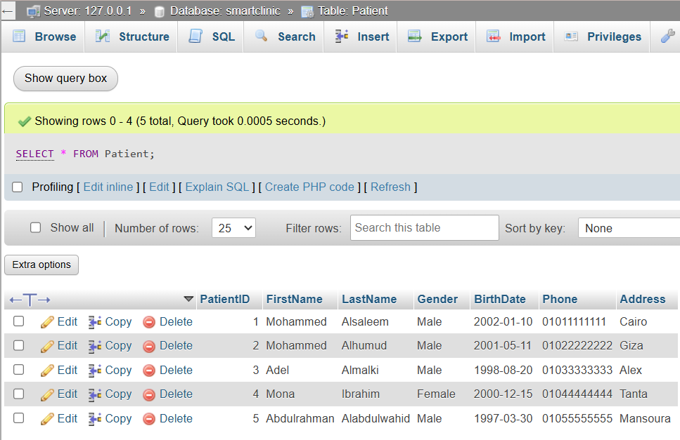
Description:
This query retrieves all records from the Patient table to display patient information

-- Another SELECT statement
SELECT FirstName, LastName, Phone FROM Patient;
Screenshot:
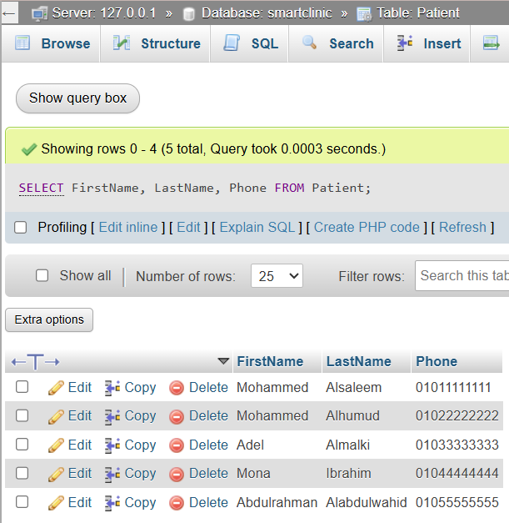
Description:
This query displays the patient's first name and last name and phone number only

-- JOIN query
SELECT
P.FirstName,
P.LastName,
D.Specialization,
A.AppointmentDate,
A.AppointmentTime
FROM Appointment A
JOIN Patient P ON A.PatientID = P.PatientID
JOIN Doctor D ON A.DoctorID = D.EmployeeID;
Screenshot:
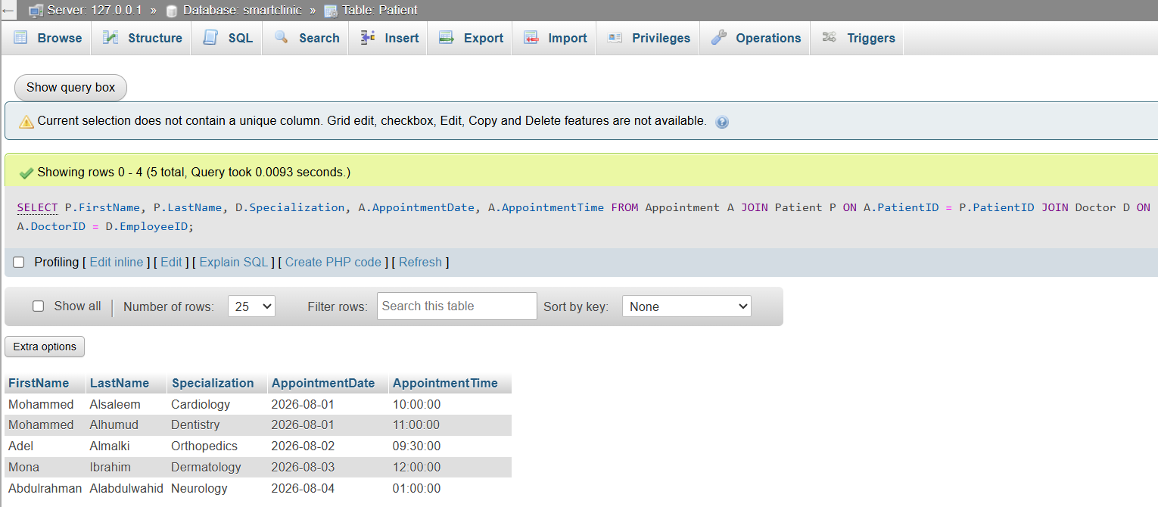
Description:
This query joins the Patient’s first name and Patient’s last name from Patient table and Appointment date and time from Appointment table and Doctor’s specialization from Doctor table to display appointment details along with patient and doctor information

-- Nested query
SELECT Name FROM Employee WHERE EmployeeID
IN (SELECT DoctorID FROM Appointment);
Screenshot:
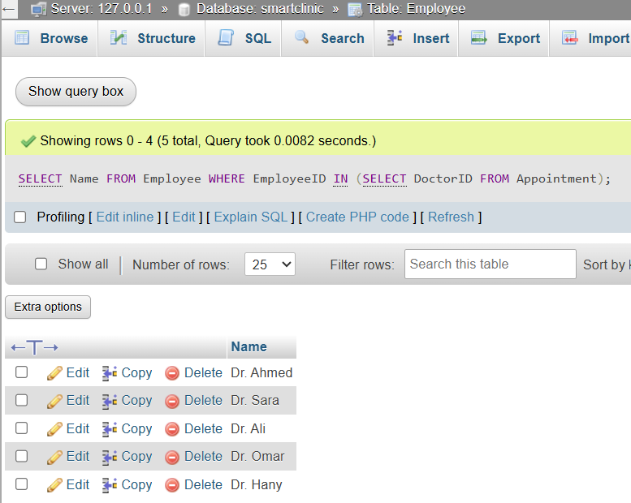
Description:
This query retrieves the names of doctors who have scheduled appointments

-- Aggregate function with GROUP BY
SELECT DoctorID, COUNT(*) AS TotalAppointments
FROM Appointment GROUP BY DoctorID;
Screenshot:
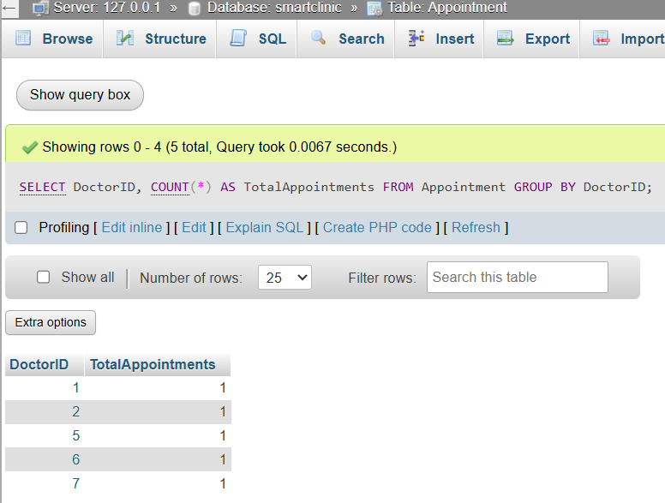
Description:
This query counts the total number of appointments assigned to each doctor

-- UPDATE statement
UPDATE Patient SET Phone='01099999999' WHERE PatientID=1;
Screenshot:
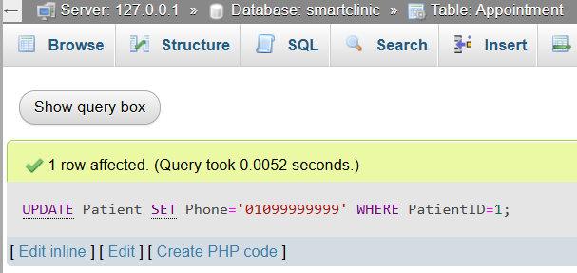
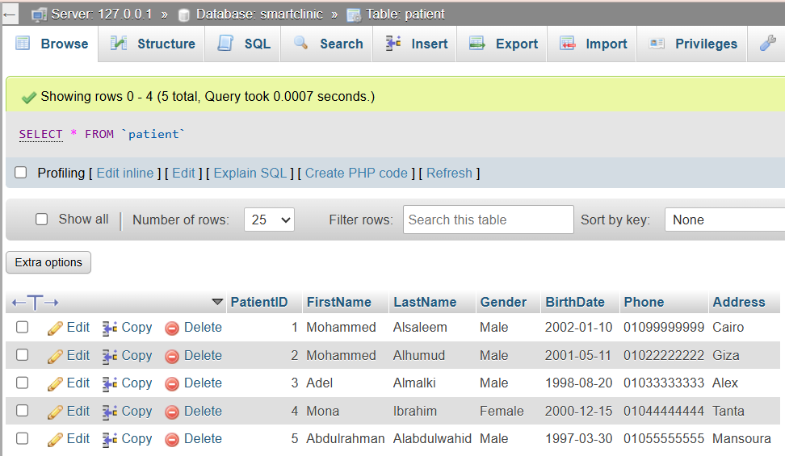
Description:
This query updates the phone number of a specific patient that his PatientID is 1

-- DELETE statement
DELETE FROM Payment WHERE PaymentID=5;
Screenshot:
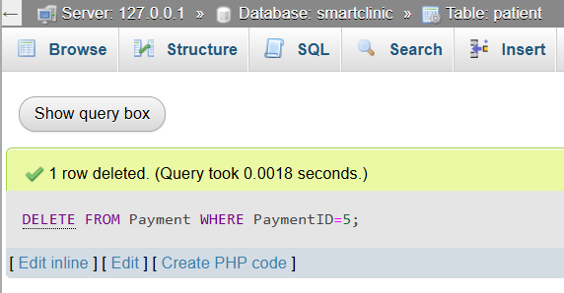
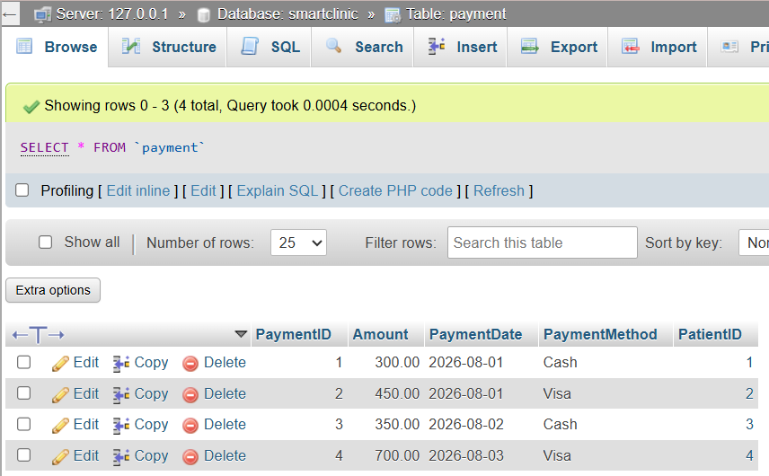
Description:
This query removes a payment record from the Payment table that his PaymentID is 5

-- Create one VIEW
CREATE VIEW PatientAppointments AS
SELECT
P.FirstName,
P.LastName,
A.AppointmentDate,
A.AppointmentTime,
A.Status
FROM Patient P
JOIN Appointment A ON P.PatientID=A.PatientID;
Screenshot:
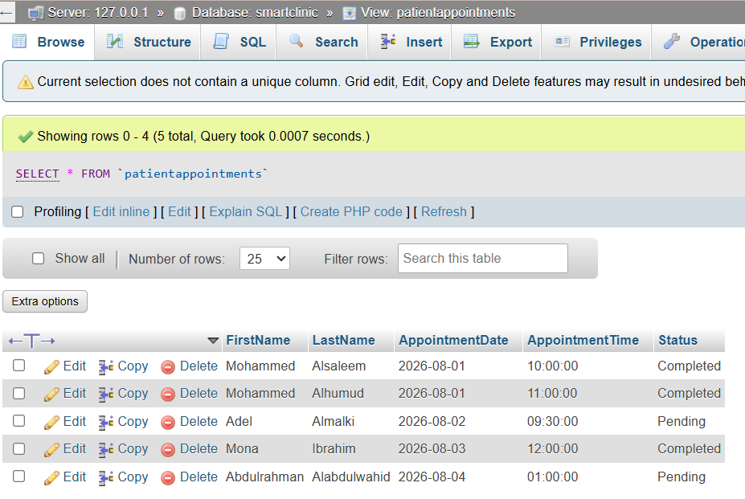

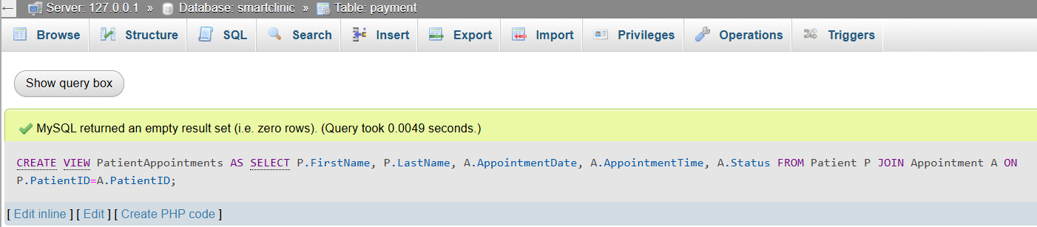
Description:
This view displays patient names together with their appointment details

-- Create one TRIGGER
DELIMITER $$
CREATE TRIGGER CheckPaymentAmount
BEFORE INSERT ON Payment
FOR EACH ROW
BEGIN
IF NEW.Amount < 0 THEN
SET NEW.Amount = 0;
END IF;
END $$
DELIMITER ;
Screenshot:
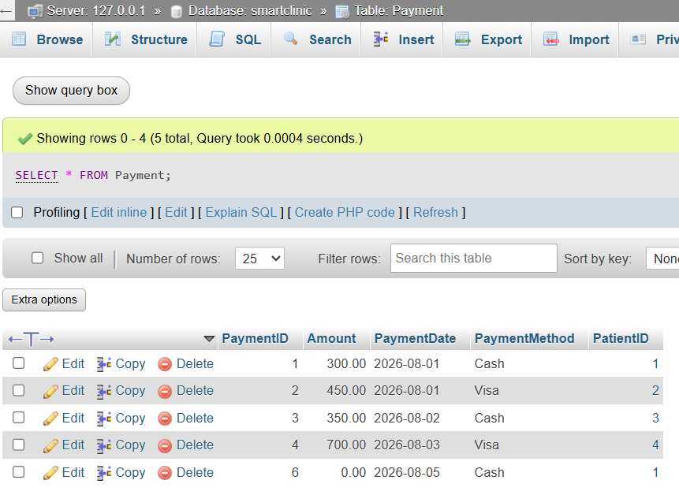
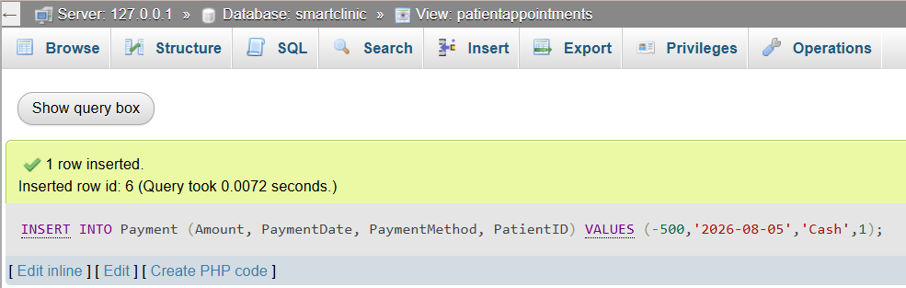
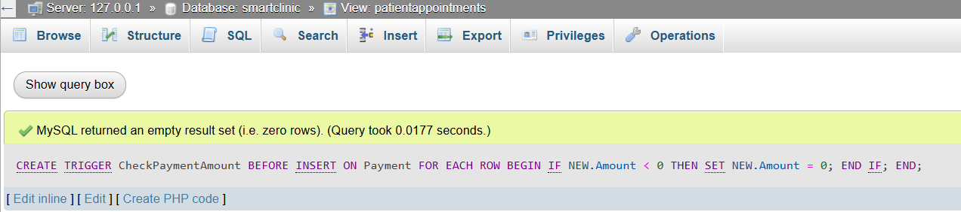
Description:
This trigger validates the payment amount before inserting a new record if the amount is negative it automatically replaces it with 0 to maintain data integrity and make example to insert negative amount

Task 4 – Reflection (2 Marks)
Write a 300–500-word reflection on your experience while completing this project by
answering the following questions. Your responses should be clear, concise, and
supported with specific examples from your own work.
- Describe one specific challenge or obstacle you encountered during this project and explain in detail how you identified and resolved it.
- Explain why you chose your specific approach/method/model over at least one alternative you considered, and what tradeoffs informed that decision.
- If you used any AI tools during this project (e.g., ChatGPT, Claude, Copilot), disclose which tool(s), for what specific purpose (e.g., debugging, grammar checking, brainstorming), and how you verified or modified the output.
- What would you do differently if you were to redo this project with more time or resources?

Answer:
Completing the Smart Clinic Database project was a valuable learning experience that improved my understanding of database design and SQL implementation on of the biggest challenges i faced was designing the relationships between the tables while maintaining proper normalization at first i was unsure how to connect the Employee and Doctor and Receptionist entities without creating redundant data after reviewing the project requirements and analyzing the relationships, we decided to use specialization in the EER model where Employee became the superclass and Doctor and Receptionist became subclasses this approach reduced data duplication and made the database structure more organized.

When designing the database i considered two different approaches the first approach was to create completely separate tables for doctors and receptionists each containing all employee information the second approach was to use a superclass Employee with specialized subclasses i chose the second approach because it follows good database design principles and avoids repeating common attributes such as name and phone and number and email and salary Although this method required additional foreign key relationships and slightly increased the complexity of the design it provided better scalability and easier maintenance if new employee types were added in the future.

We didn’t use any AI tools while completing this project. All aspects of the database design and SQL and implementation were completed independently.

If i had more time and resources we would expand the project by adding more advanced features for example we would create additional tables for departments and prescriptions and medical records we would also implement stored procedures more complex triggers and additional SQL views to improve the functionality of the system we would spend more time testing different scenarios and improving the user documentation overall this project strengthened my practical knowledge of database design and SQL programming and the importance of careful planning before implementation

Deliverables
- Project Report (PDF) – System description, ER/EER diagram, relational schema, SQL code, screenshots, and reflection.
- SQL Script (.sql) – Complete SQL implementation of the project.
- GitHub Repository – Repository link with the complete project and commit history.
- Mid-Project Progress Report – Summary of progress, challenges, decisions, and team contributions.
- Project Artifacts
  - Live report document (with edit history): [link]
  - GitHub/GitLab repository (with commit history): [link]
  - Google Colab notebook (if applicable): [link]

Live report document: https://docs.google.com/document/d/1t8yur5ryPM2rHABlqd1xwSC6OzaoQex7-j6-s_HIZio/edit?usp=sharing

GitHub/GitLab repository:
https://github.com/alsaleemmohammed076-crypto/Smart-Clinic-Database.git

